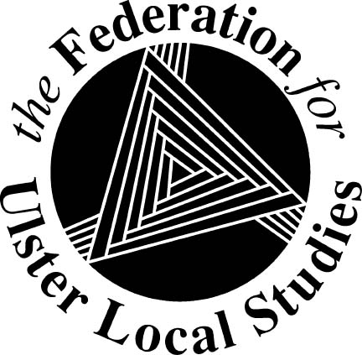
The Federation for Ulster Local Studies Ltd

18 Ardmore Avenue, Downpatrick, Co Down BT30 6JU
Tel: 07530067256
Email: info@fuls.org.uk
Website: http://www.fuls.org/
Company No. NI 027863 Charity No. NIC 100526

ANNOUNCING

JOINT FLHS/FULS TRIP

TO
SOUTH EASTERN ENGLAND

- Date to be decided -
Visiting

Canterbury, Portsmouth, Winchester and London
(venues may change before final plan)

[More information later]

