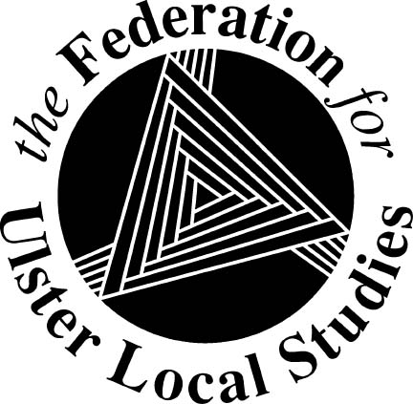
The Federation for Ulster Local Studies Ltd

18 Ardmore Avenue, Downpatrick, Co Down BT30 6JU
Tel: 07530067256
Email: info@fuls.org.uk
Website: http://www.fuls.org/
Company No. NI 027863 Charity No. NIC 100526

ANNOUNCING

SPRING SEMINAR

On Local Heritage

Saturday
4 APRIL 2019

In

HOMEPLACE

Seamus Heaney Centre
Bellaghy

[More information later]

